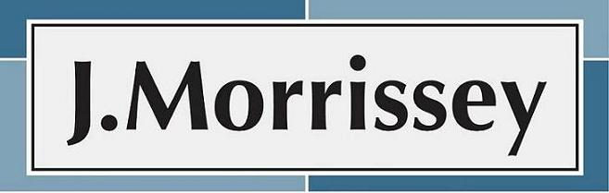

The Huntington House 289 Broad Street Windsor, CT 06095
Tel: 860-925-6000 Fax: 860-640-6544 www.jmorrissey.com

VICE PRESIDENT HUMAN RESOURCES OPPORTUNITY

J. Morrissey & Company has partnered with Ability Beyond, of Bethel CT, to add the new VP Human Resources to the senior leadership team. This individual is responsible for leading the human resources function and supporting the growth of this mission driven, non-profit organization. The human resources leader will ensure all functions including compensation, benefits, employee relations, talent management, talent acquisition, training and organizational development are managed and implemented effectively. In addition, this individual will establish programs fostering an employee experience that drives attraction, retention and sustainable engagement as well as reinforces the importance of customer service.

“Ability Beyond is one of the most comprehensive systems of community-based support for people with disabilities in the Northeast, helping more than 2,500 people across two states to overcome a variety of challenges. It is through our innovative community job training and placement, supported living, and recreational and educational opportunities that we are able to help the individuals we serve to live full and rewarding lives. Ability Beyond employs over 1,100 dedicated staff, engages over 500 volunteers and is governed by a voluntary Board of Directors and Trustees. Ability Beyond has an annual operating budget of $68 million and receives community support in excess of $2 million annually.”

Candidates who wish to be considered will be required to participate in J. Morrissey’s comprehensive search process. Initially, candidates must meet the following required qualifications:

- Minimum of 15 years of progressive human resources, holding leadership roles in fast-paced, progressive organizations; non-profit experience is desirable.
- Master’s Degree or SPHR required
- Proven experience in all areas of human resources with a strong focus on organizational development, talent management including recruitment, succession planning, leadership development, coaching and performance management.
- Possess a strong business orientation and human resources philosophy that positions human resources solutions in business terms with a strong customer service orientation.

For confidential inquiries, please contact
Donna R. McCarty, Senior Vice President & CAO
J. Morrissey & Company, Inc.
mccarty@jmorrissey.com (860) 925-6000 x112

